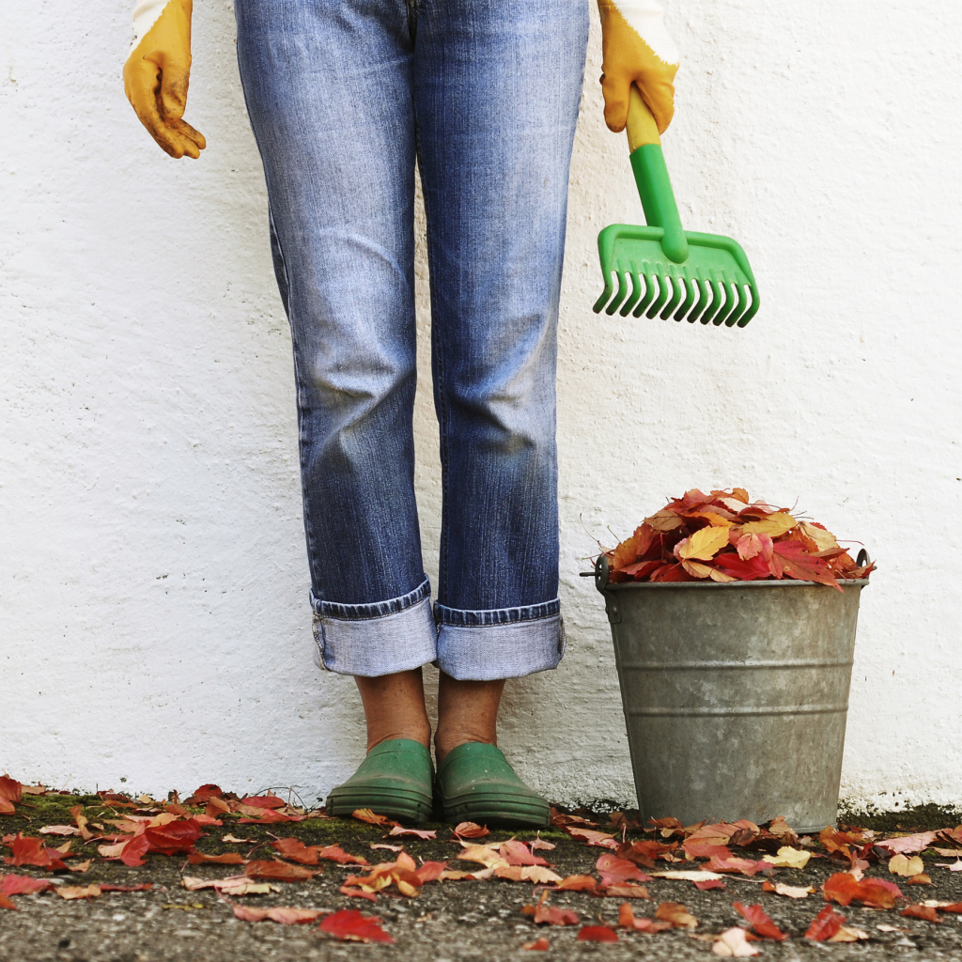  edible flint  - Fall 2017  For more information on Fall classes and to register for the 2017 Fall Harvest Festival, please visit our website edibleflint.org or call (810) 244-8527  “edible flint programs and materials are open to all without regard to race, color, national origin, gender, religion, age, disability, political belief, sexual orientation, gender identification, marital status or family status.” | Events  Business Planning for Producers September 11th 5 pm- 6pm  Fall Harvest Festival September 21st 5 pm- 8 pm  Workshops at the Demo Garden October 14th October 28th 10 am- 3pm  Crop Planning for Producers  edible flint  605 N. Saginaw St Ste 1A  Flint, MI 48502  (810) 244.8530  edibleflint.org

