What has been done around soil testing in Flint?
Edible Flint has been testing soils in Flint every year from 2011 to 2017, collecting a total of 459 samples from area gardens. We test soils for several nutrients and micronutrients, as well as contaminants including lead. We also expanded testing in 2016.

Why do we care about soil testing?
We test soils as a precaution to inform people whether their soil is suitable for gardening, to help people manage their soil fertility, and to screen for potential contamination with lead. Lead naturally occurs in soils but large quantities can be bad for your health.

What is the risk for lead in soil?
The risk for lead in the soil is through breathing lead dust or eating lead through plants grown in the soil. Soil dust or particles on the surface of fruits and vegetables is the primary concern for food grown in lead contaminated soil. Most vegetables do not easily absorb lead from soil or water.

Where might lead in soil be an issue?
Certain previous land uses were more likely to have lead in products on site. These lead sources included gasoline, paint in buildings, and industrial operations), and therefore contributed lead to the environment. It can be difficult to know whether or how much a property was affected by any of these contaminants, so we recommend soil testing before you start a garden.

What do these results mean?
We are fortunate here in Flint when it comes to soil lead contamination: 91% of gardens tested fall below a 300 ppm limit. Above this limit, edible flint recommends alternative methods for planting food crops.

Did our soil levels get worse after the water crisis?
Testing has shown that our soil lead levels did not measurably change in gardens that were watered with Flint water during the summers of 2014 and 2015.

How do we compare to other cities across the United States?
Our lead results are not nearly as high as other US cities. The graph below shows the percentage of gardens that are acceptable at various thresholds. For example, 63% of our gardens fall below the strictest threshold of 80 ppm, while other cities do not fare as well (Baltimore = 45%, in red, Reading, PA = 10%, in light blue). Similarly, 97% of our gardens fall below 400 ppm (a commonly used EPA low threshold), while other communities still fare poorly (Chicago = 25%, in dark blue, Boston = 12%, in maroon).

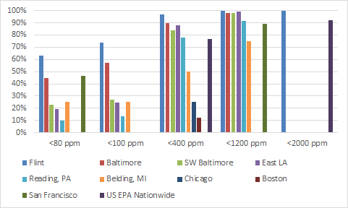

What do I do if my soil level is high?
If your garden soils are above 300 ppm, we don’t recommend gardening directly in the soil. Building raised bed garden boxes or using planters filled with known good soil are two options. You might also consider gardening on another plot of land (perhaps at a church or other community site). We are happy to connect community members to potential alternatives.

How do I minimize my risk for soil lead exposure?
Wear gloves and shoes while gardening, and avoid tracking soil into your home. Wash produce before consuming, peel root crops and discard the outer and older leaves of leafy vegetables. Fruiting crops like tomatoes, beans, peas, and squash are considered low risk crops, so you can plant these. Even when gardening in low lead soils (<300 ppm), improve soil health by adding organic matter like compost and maintaining a soil ph between 6.5 and 7.5.

What is the broader message?
You can still garden here in Flint! The vast majority of gardens fall well within strict limits for safe gardening. As a precaution, we do encourage everyone (especially people gardening in older neighborhoods) to get their soil tested just to be sure.

